**DAILY ONLINE ACTIVITIES SUMMARY**

|  |  |  |  |  |  |  |  |  |
| --- | --- | --- | --- | --- | --- | --- | --- | --- |
| **Date:** | 18/05/2020 | | | | | **Name:** | D Richard Franklin | |
| **Sem & Sec** | Fourth SEM section A | | | | | **USN:** | 4AL18CS020 | |
| **Online Test Summary** | | | | | | | | |
| **Subject** | | Design and Analysis of Algorithms | | | | | | |
| **Max. Marks** | | 30 | | **Score** | | | 19 | |
| **Certification Course Summary** | | | | | | | | |
| **Course** | Complete Python Bootcamp : Go from zero to hero in Python 3 | | | | | | | |
| **Certificate Provider** | | | Udemy | | **Duration** | | | 2 Hours |
| **Coding Challenges** | | | | | | | | |
| **Problem Statement:** 1. To check whether one string is a sub sequence of another string  2. To find the short palindrome of a string  3. To check if a inked list is a palindrome or not using stacks | | | | | | | | |
| **Status:** Completed | | | | | | | | |
| **Uploaded the report in Github** | | | | | YES | | | |
| **If yes Repository name** | | | | | <https://github.com/richard3658/lockdown-coding> | | | |
| **Uploaded the report in slack** | | | | | YES | | | |

**Online Test Details:**

The online test was from module 1 which was about Introduction to the subject and asymptotic notations. There were 25 questions and the duration was 30 minutes. The questions were optimal and were easy. The score that I received was 19/30.

**Snapshot**: not taken

**Certification Course Details:**

**Name of the course**: Complete Python Bootcamp: Go from zero to hero in Python 3

**Certificate Provider**: Udemy

This course has 19 sections and the total duration is 24 hours.

In the second day I went through the second section of the course and learnt the different data structures available in python and heir usages.

**Snapshot:**

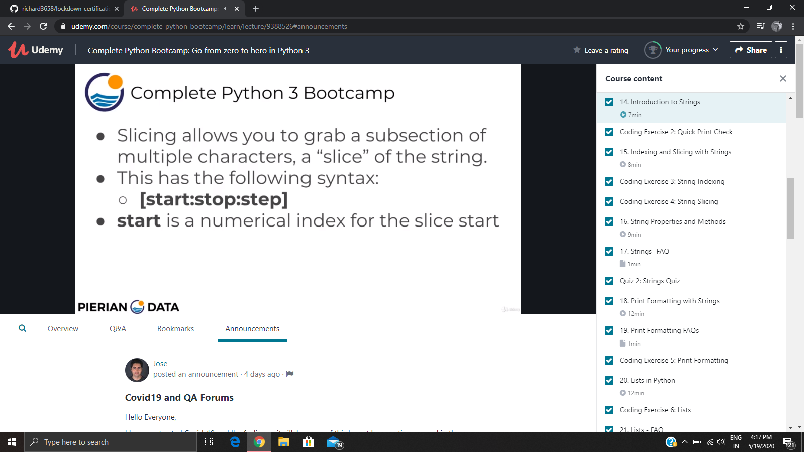

**Online Coding Details:**

Problem 1: (using C language) A user will input two strings, and we find if one of the strings is a sub sequence of the other. Program prints “yes” if either the first string is a sub sequence of the second string or the second string is a sub sequence of the first string. Assume that, the length of the first string is smaller than or equal to the length of the second string.

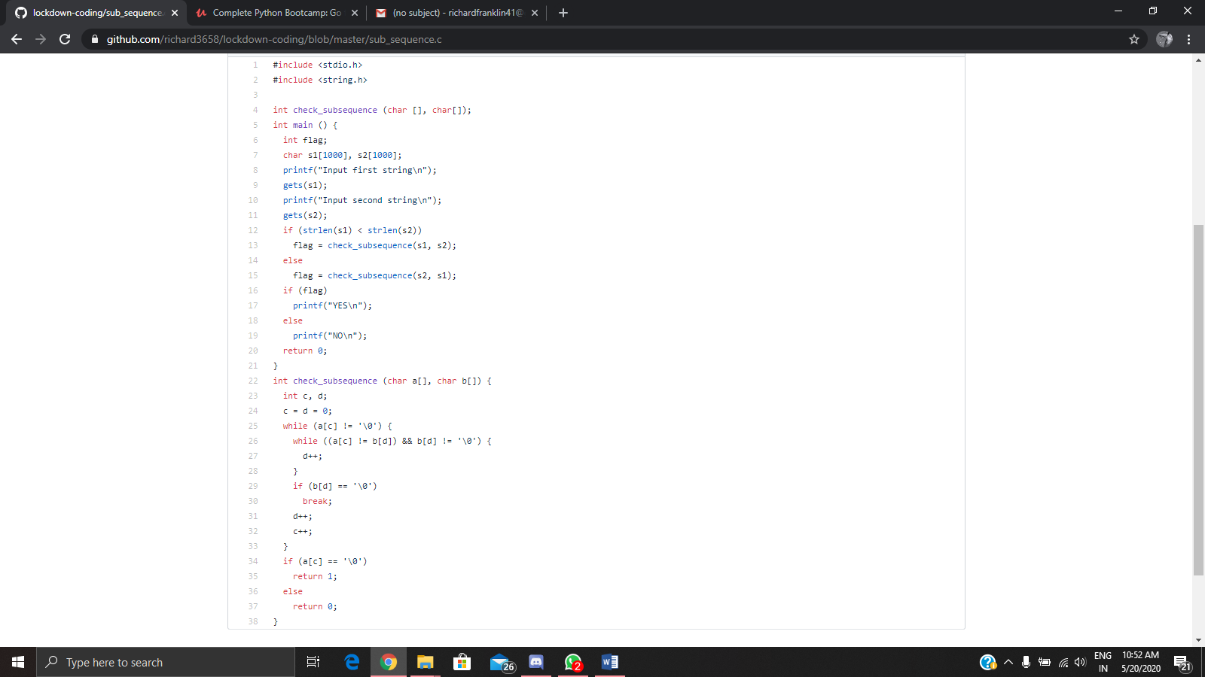

Problem 2: (Using JAVA) We have a Letter or a word then we need add some letters to it and need to find out shortest palindrome. For example we take “S”, “S” will be the shortest palindrome string. If we take “xyz”, “zyxyz” will be the shortest palindrome string. So we need to add some characters to the given string or character and find out what will be the shortest palindrome string.

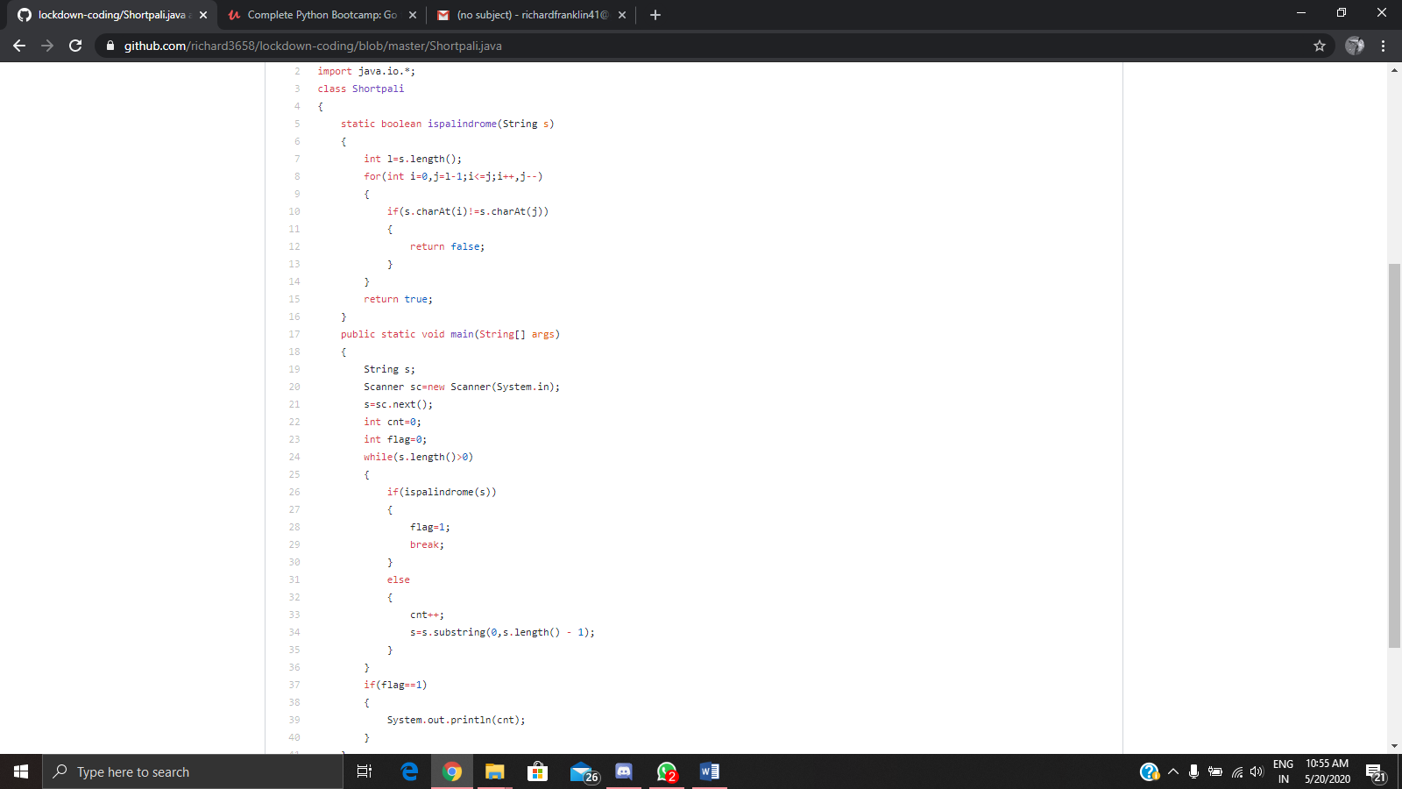

Problem 3: Write a simple code to identify given linked list is palindrome or not by using stack.  
First take a Stack. Traverse through each node of the linked list and push each node value to stack. Once the traversal & copying is done, iterate through linked list from head node again.  
In each iteration, pop one stack element and compare with node value in respective iteration. It is expected to match stack popped value with node value. In case of all matches, it’s a palindrome. Any one element mismatch makes it not a palindrome.

